Software Requirements Specification Template

Paddle My Way

Software Requirements Specification

Version 2.0

04/25/2023

TEAM MEMBERS

Nikhila Chowdary Vaitla(S546518)

Padmavathi Maddukuri(S546956)

Manoj Kumar Barugu(S546292)

Pranay Kumar Pavuluri(S546959)

Kousalya Dasari(S546651)

Lakshmi Prathyusha Bavanam(S546663)

Submitted in partial fulfillment of the requirements of

CSIS 44-691 Graduate Directed Project 1

# Revision History

|  |  |  |  |
| --- | --- | --- | --- |
| **Date** | **Description** | **Author** | **Comments** |
| <date> | <Version 1> | <Your Name> | <First Revision> |
|  |  |  |  |
|  |  |  |  |
|  |  |  |  |

# Document Approval

The following Software Requirements Specification has been accepted and approved by the following:

|  |  |  |  |
| --- | --- | --- | --- |
| **Signature** | **Printed Name** | **Title** | **Date** |
|  |  |  |  |
|  |  |  |  |
|  |  |  |  |

**Table of Contents**

**Table of Contents Page Number**

1. Introduction
   1. Purpose
   2. Scope
   3. Definitions, Acronyms, and Abbreviations
   4. References
   5. Overview
2. General Description
   1. Product Perspective
   2. Product Functions
   3. User Characteristics
   4. General Constraints
   5. Assumptions and Dependencies
3. Specific Requirements
   1. External Interface Requirements
      1. User Interfaces
      2. Hardware Interfaces
      3. Software Interfaces
      4. Communications Interface
   2. Functional Requirements
   3. Use Cases
   4. Class/Objects
   5. Non-Functional Requirements

3.5.1. Performance

3.5.2. Reliability

* + 1. Availability
    2. Security
    3. Portability
  1. Design Constraints
  2. Logical Database Requirements
  3. Other Requirements
  4. Prototypes (for complete project)
  5. Use Case Diagrams

1. Design

4.1. ER diagram

4.2. GUI

1. Analysis Models

5.1. Data Flow Diagram

5.2. Sequence Diagram

5.3 Implementation Components

6. User Manual

6.1 Launching Application

6.2 Login/Register

6.3 Forgot Password

6.4 Global Search

6.5 Live Chat

6.6 Filtering of Data

6.7 Calendar in Wishlist Screen

6.8 Ratings and Reviews

6.9 Payment Gateway

6.10 History of Trips

7. Technical Manual

7.1 Targeted Audience

7.2 Purpose

7.3 Scope

7.4 Software Installations

7.5 List of packages in project

7.6 Side Navigation Bar

7.7 Cells Package

7.8 Models Package

7.9 Controller Package

7.10 Products and Pods Package

8. Conclusion

**1. Introduction**

**1.1 Purpose**

This project includes a thorough examination of the tour and travel management system. The main goal of this program is to give travelers the best trip plans depending on parameters such as the number of people, the type of category, and the season. Because it prompts the user to enter the details, searching will be very simple. The user will be able to retrieve the relevant info with a single click. This project will provide relevant information on location descriptions. People who are going to travel will benefit from the Paddle My Way (Tour & Travel) method.

**1.2 Scope**

The main scope of the project is described below:

* The main goal of the project is to provide information on places that tourists desire to visit and features to identify popular tourist spots, events, and so on in that area.
* This project includes exclusive features such as the number of places to visit and budget calculation based on the number of people selected by the user, as well as extended features such as updated information of the places that are booked, booking history, generating reviews based on the travel experience, and photos uploaded by the user.

**1.3 Overview**

Our product is about travel planning, and the user needs to join up and then login to find cheap locations to stay. Following the selection of the region, the user must define the season as well as the sort of group with which they are traveling. This software includes a list of sites and events to visit, as well as a description of each location in that region. We present different plans for that region up to a 5-day plan after the region is selected. The user can specify the date and number of persons traveling based on the Wishlist of the trip. After their trip, the user can also leave feedback for the locations they visited. The user can also view their prior and upcoming travel reservations.

**2. General Description**

In our project, we are creating an iOS application that requires users to sign up and then login to identify friendly areas. After selecting the region, the user must choose the season and the type of individuals with whom they wish to visit. The application will include details such as events in the trip, best places to visit nearby, best season to visit the area, total number of days of the plan, and reviews of the places based on their criteria for the plan. The user will also be able to view their previous bookings in history and upcoming travel bookings.

**3. Specific Requirements**

**3.1. External Interface Requirements**

We will be having external websites like different event booking websites for each location.

**3.1.1. User Interfaces**

We are designing a user interface with the help of Swift programming Language.

**3.1.2. Hardware Interfaces**

1. Operating System (32- or 64-bit iOS)
2. Processor (1 dual core or single core processor)

**3.1.3. Software Interfaces**

* XCODE

**3.1.4. Communications Interface**

The Communication Interface which is used for the project is Appstore.

**3.2. Functional Requirements**

**3.2.1. Customer side: -**

* Ability to sign up/login into the application.
* Ability to reset the password the user forgot password using link sent to Gmail provided.
* Ability to search for the tourist place after successfully logging in and view the results from the search list of the application.
* Ability to redirect to the external website based on the provided URL for events.
* Ability to chat with admin for any queries.
* Ability to search for the different day plans for each location.
* Ability to filter locations based on the seasons and type of group and sort for the events.
* Ability to Wishlist the desired locations.
* Ability to Add the wish listed locations to cart and get the final price based on locations and no of people.
* Ability to rate and review the completed travel.
* Ability to check past travel in history and future travel plan in booking.

**3.2.2. Administration side: -**

* Ability to login in the user.
* Ability to display the requested information from the customer.
* Ability to display the places which the user is referring to or searching for.
* Ability to chat with the user and answer queries.

**3.3. Use Cases**

The primary goal of this project is to provide all of the details such as destination information, a list of famous locations in the destination, 1–5-day plans for each category of groups based on the season, and rating of the places and travel preferences on a single application, which helps customers save valuable time and money.

**3.4. Class/Objects**

We will create the classes accordingly once we start implementation of the project.

**3.5 Non-Functional Requirements**

**3.5.1. Performance**

Performance is the objective measurement and perceived user experience of an application. This includes the following major areas:

1. Reducing overall load time
2. Making the site usable as soon as possible
3. Smoothness and interactivity

**3.5.2. Reliability**

The fundamental problem in applications is reliability. It essentially contains the elements that make programs robust, useable, mature, and effective. It is concerned with the failure rate of applications.

**3.5.3. Availability**

The ability of users to access and use a program is referred to as availability. It is usually expressed as a percentage over a specific time.

**3.5.4. Security**

Application security refers to a range of techniques, technologies, or strategies for safeguarding APIs from attack by Internet-based dangers, such as Apple's App Sandbox.

**3.6 Design Constraints**

The solution to the production of a new application is system design. We concentrate on the detailed implementation of the building application at this phase. It places a premium on translating design specifications into performance specifications. The creation of a system is divided into two stages: logical design and physical design.

During the logical design phase, the analyst describes inputs (sources), outputs (destinations), databases (data stores), and processes (data flows) in a format that fits the user's needs. The analyst also describes user requirements to the point where the information flow into and out of the system, as well as the data resources, are virtually determined. In this scenario, data flow diagrams and database design are employed to develop the logical design.

The user interface design and coding come after the physical design. Physical design develops the working system by specifying the design specifications, which tell the programmers exactly what the candidate system must perform. Programmers write programs that accept user input, process the data, and provide the needed report on paper or on the screen.

**Use Case Diagrams**

**High level Data Flow Diagram**

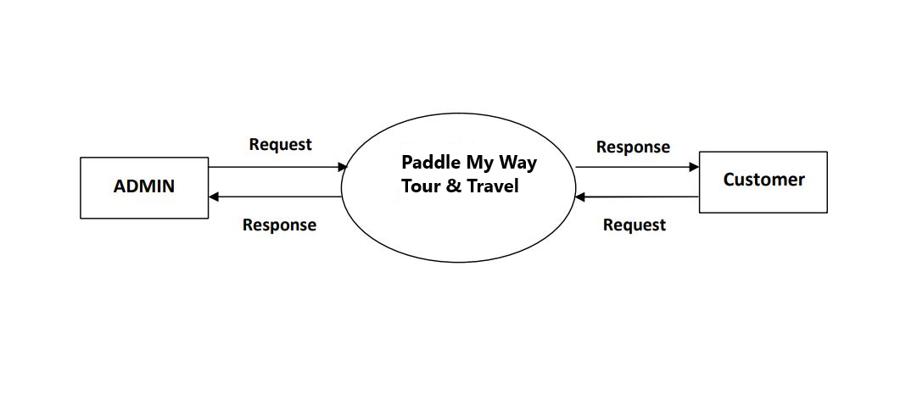

**First level Data Flow Diagram for ADMIN**

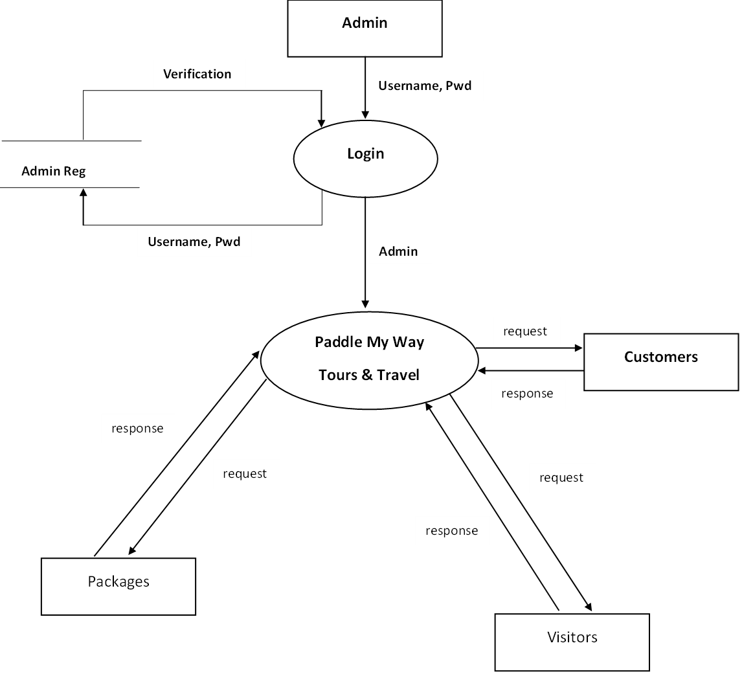

**First Level Data Flow Diagram for Customer**

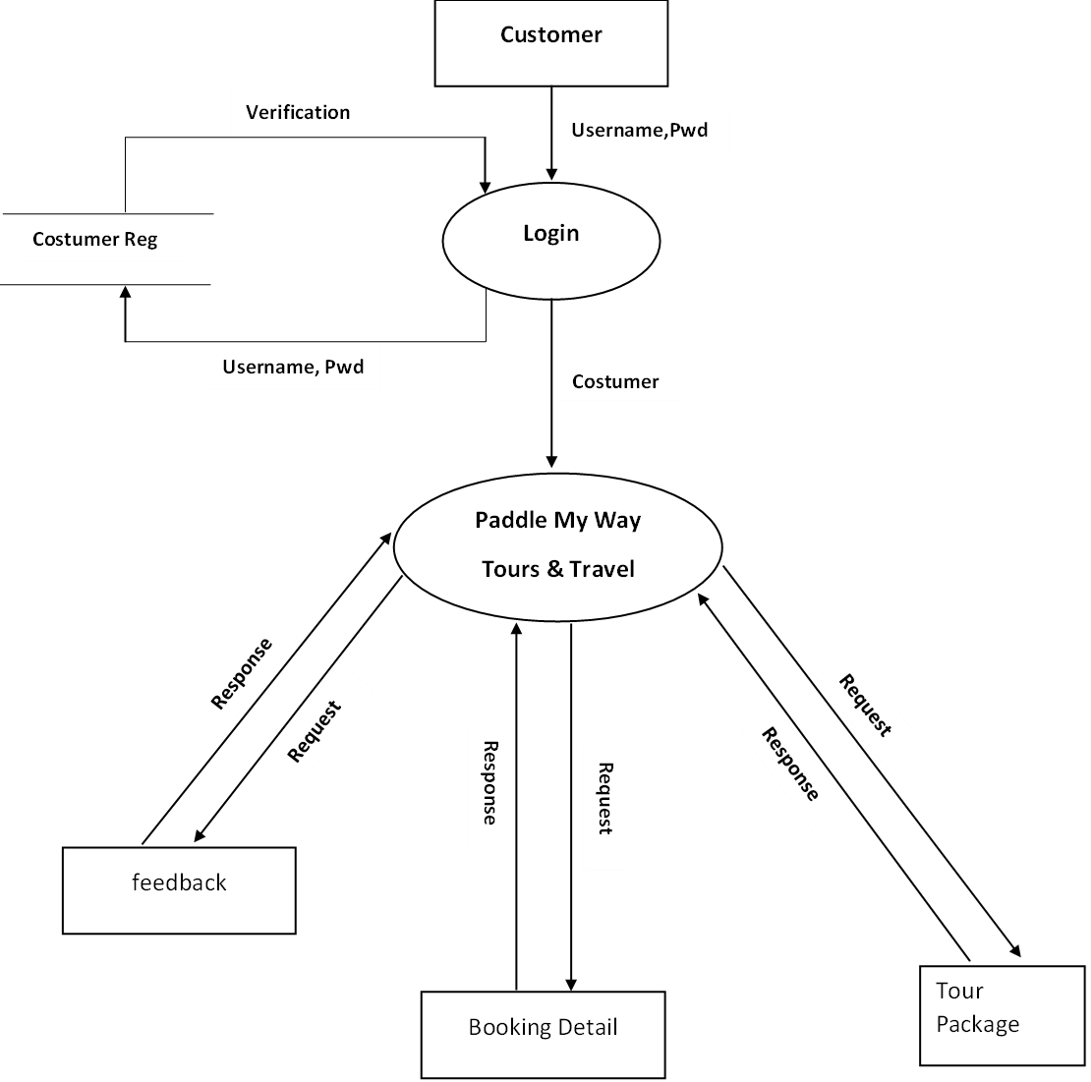

**4. Design**

**4.1. ER Diagram**

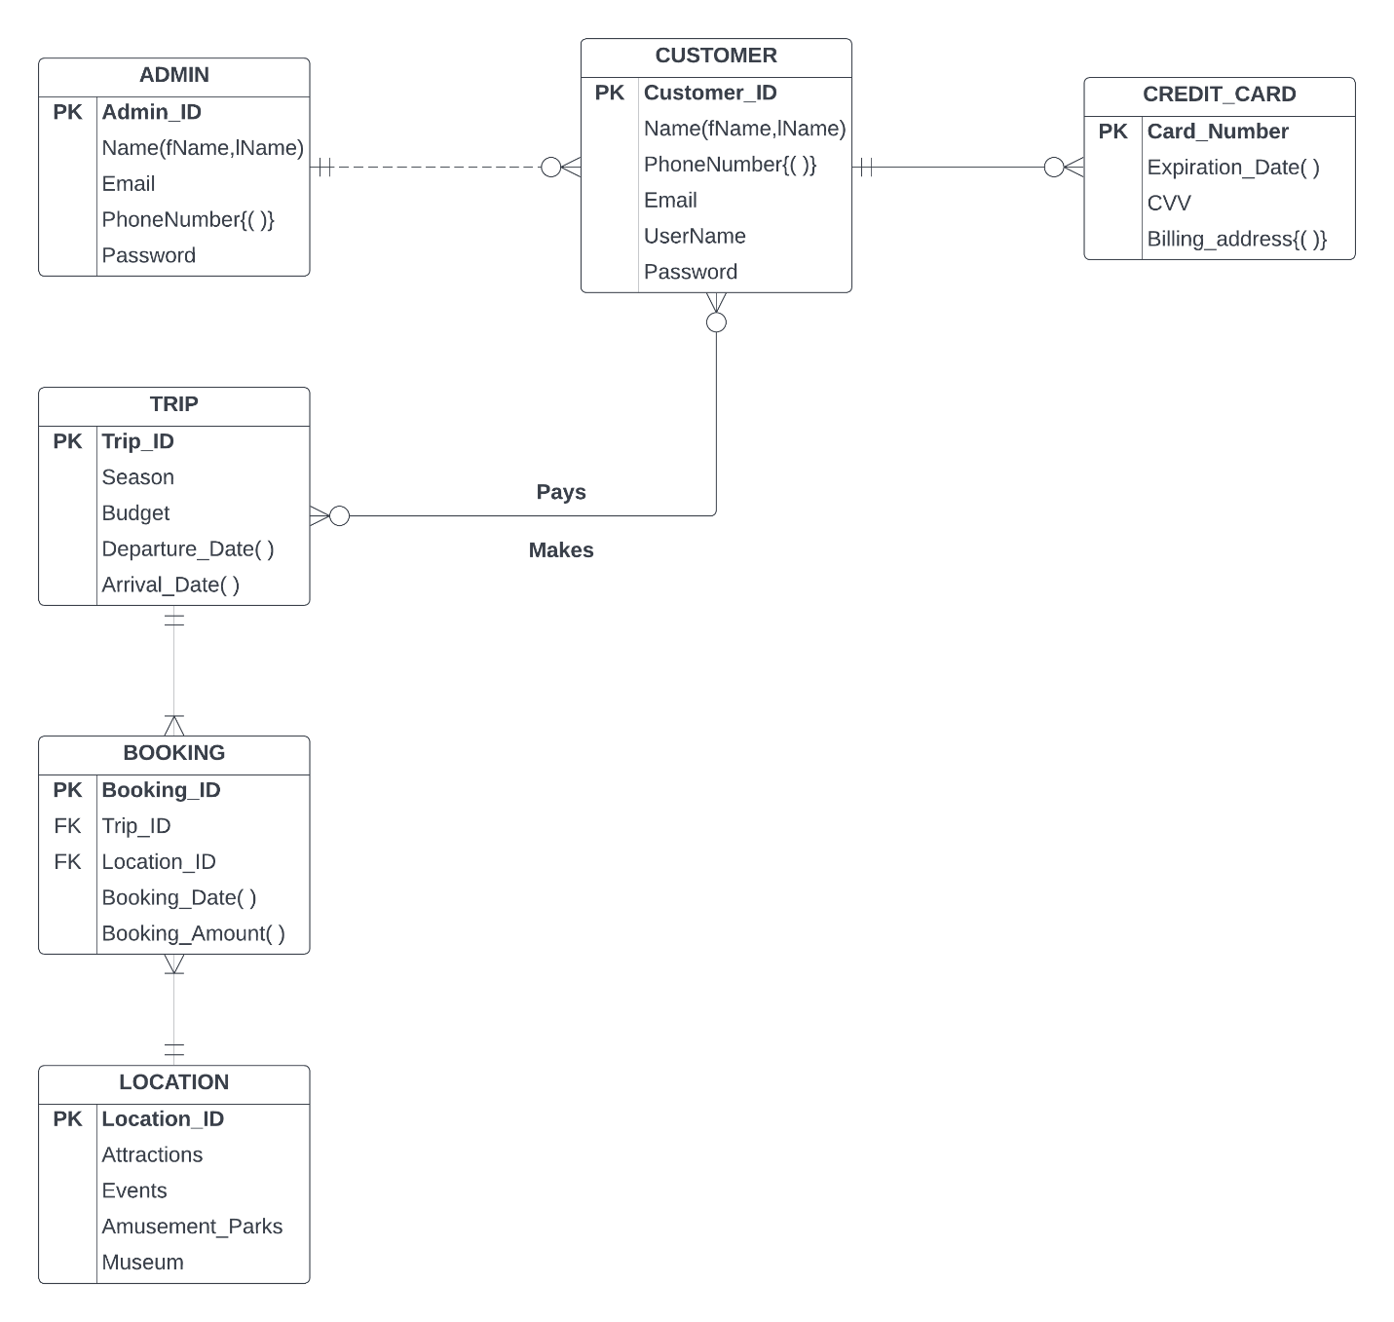

**4.2 GUI:**

**1. Home Screen**

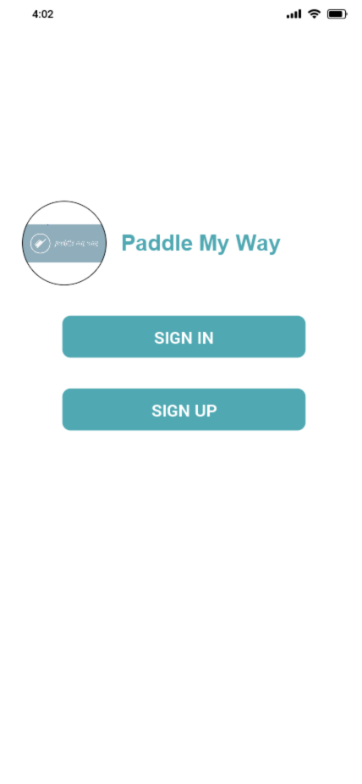

**2.Sign Up Screen**

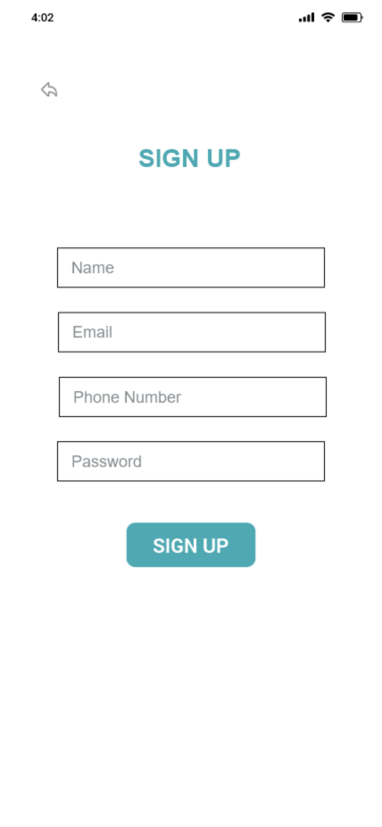

**3.Sign in Screen**

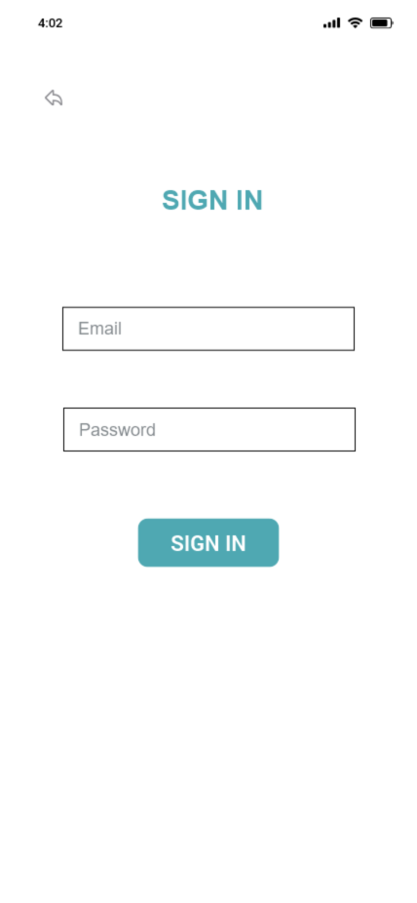

**4.Dashboard Screen**

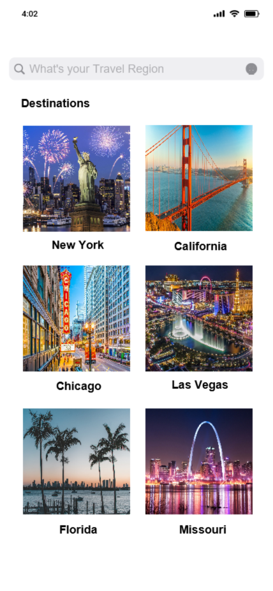

**5.Filter Screen**

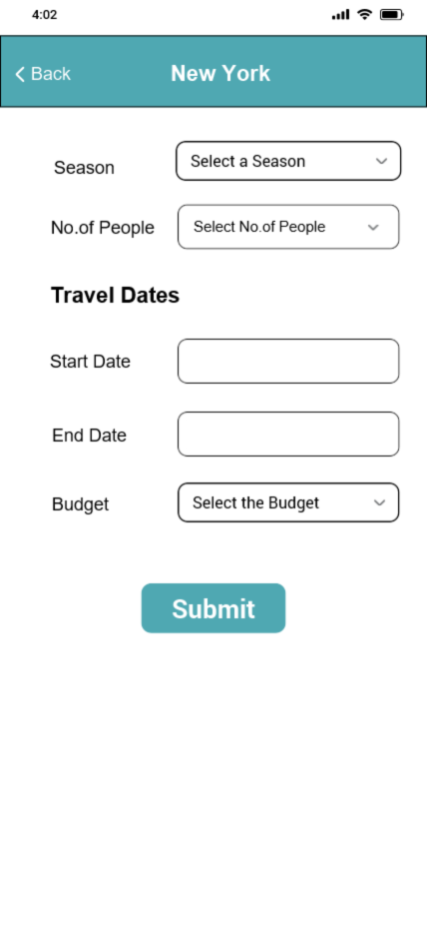

**6.Locations Screen**

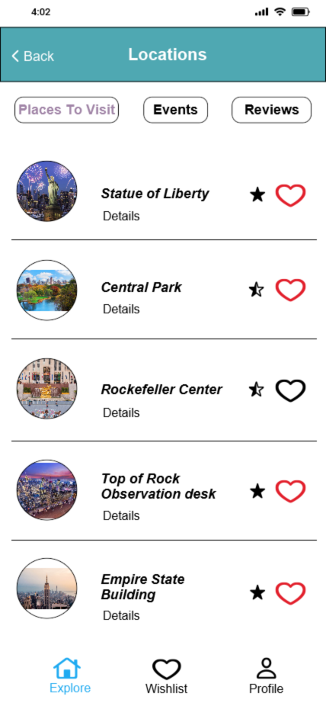

**7.Events Screen**

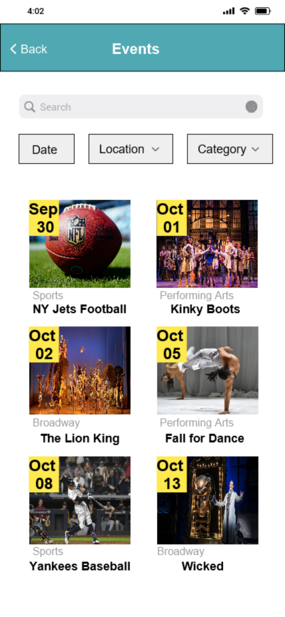

**8.Reviews Screen**

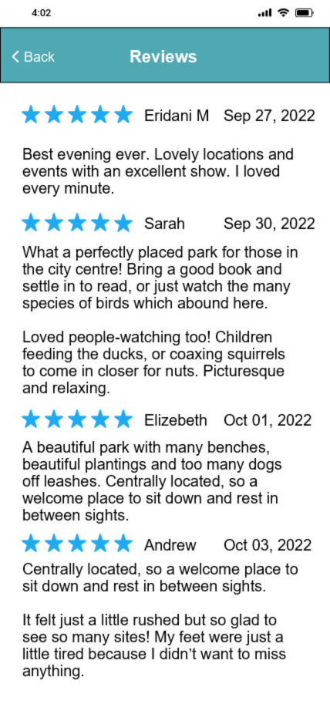

**9.Wishlist Screen**

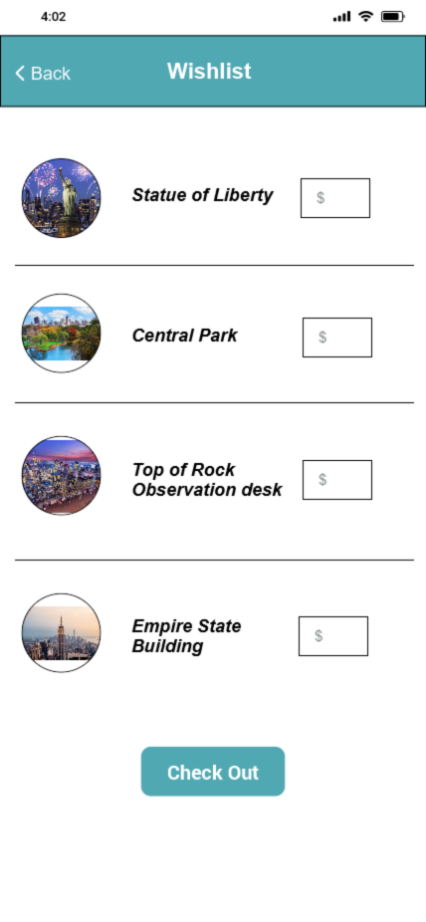

**10.Payment Screen**

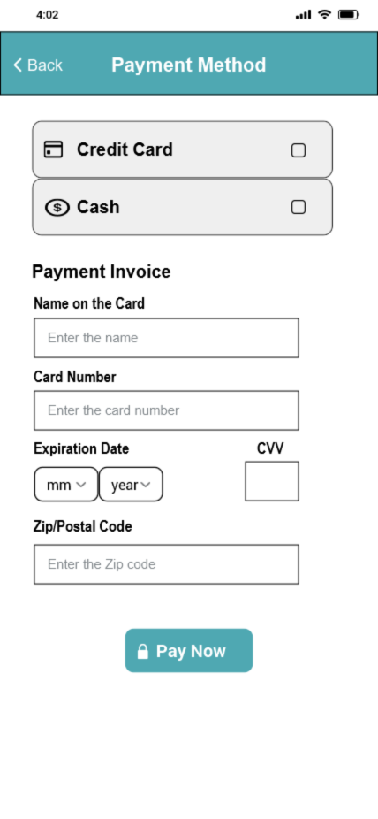

**11.Payment Confirmation Screen**

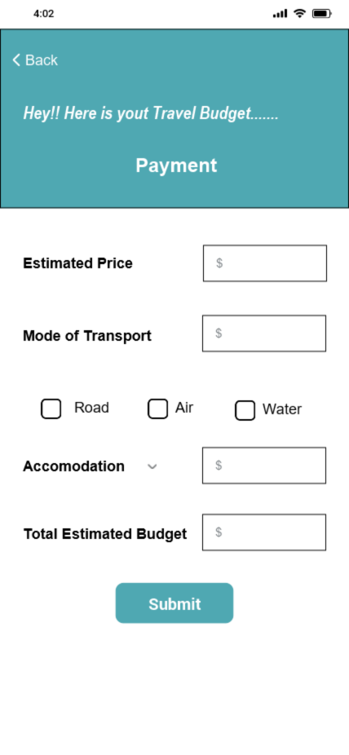

**5.Analysis Model**

**5.1 Data Flow Diagram**

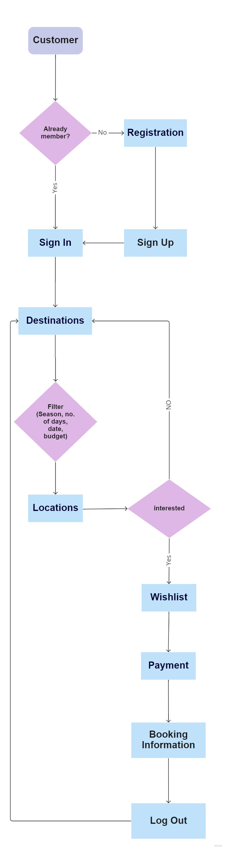

**5.2 Sequence Diagram**

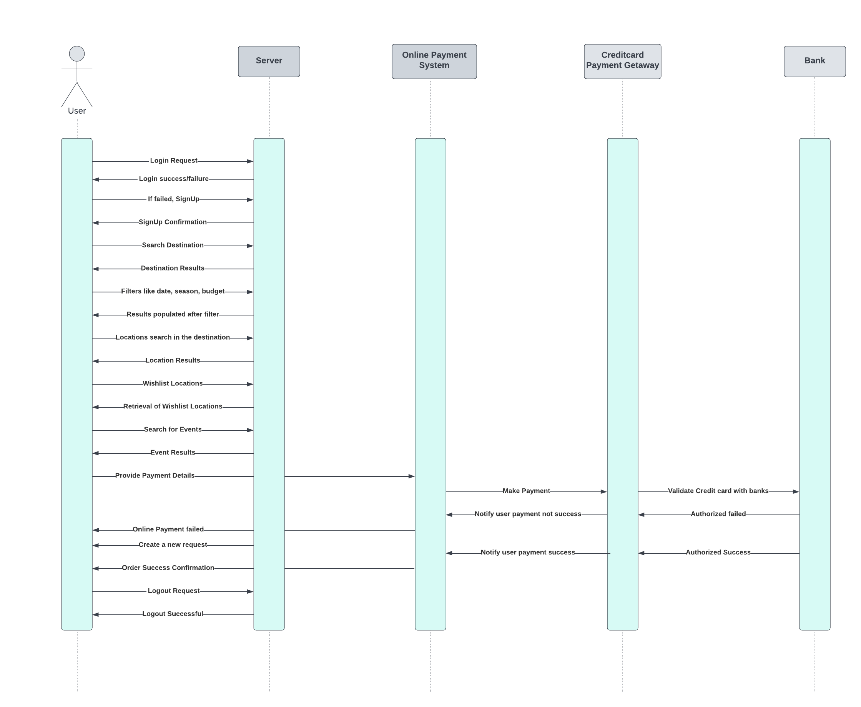

**5.3. Implementation Components**

|  |  |
| --- | --- |
| Front End | Swift (Client) |
| Back End | Swift (Backend) |
| Database | Firebase |
| Server | iOS cloud servers |

1. **User Manual**

**6.1 Launching Application:**

Users can launch the application by installing it in the App store.

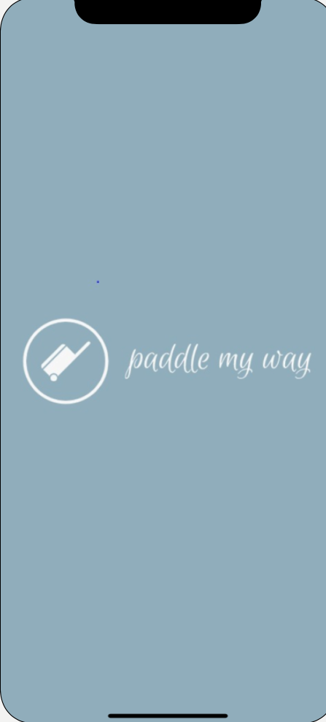

**6.2 Login/Register:**

Once the users visit the application, the user can register into the application using the Sign up and user can sign in if already an existing user.

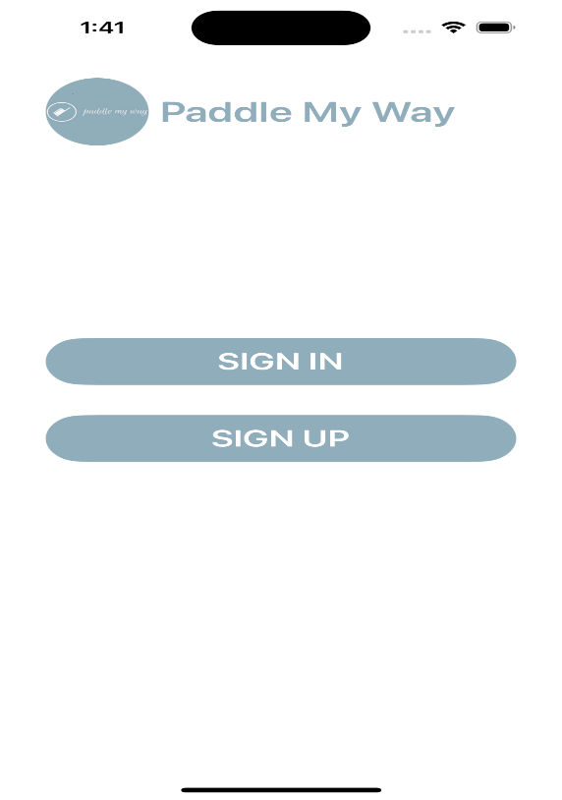

* If they are already registered with the application, they can choose Sign in and enter their credentials to enter into the application.

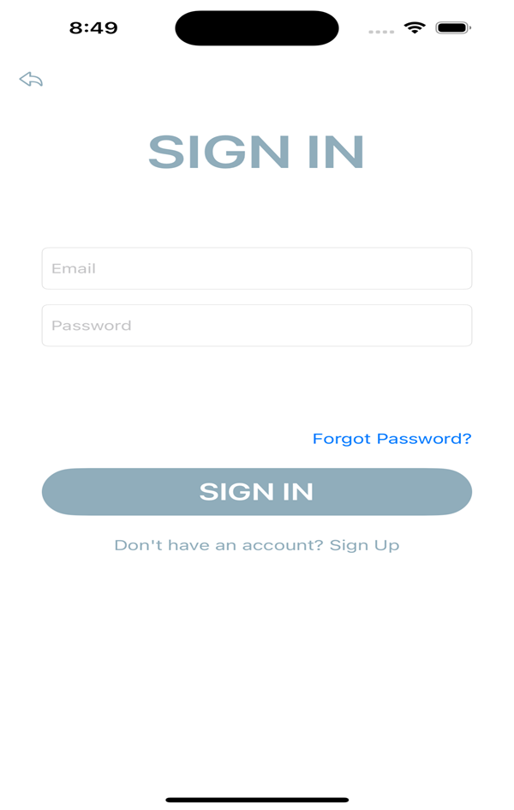

* If they are new to the application, they can choose Sign Up and get registered with the application.

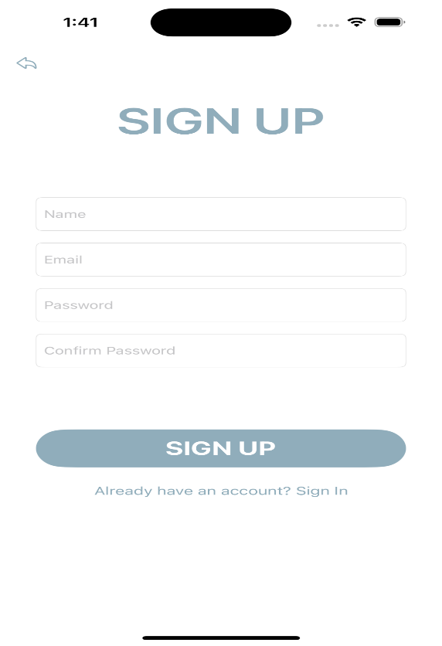

**6.3 Forgot Password:**

If the user has any login troubles, such as forgetting their password, they can click on forgot password and input their registered email address to receive an email with a link to reset their password.

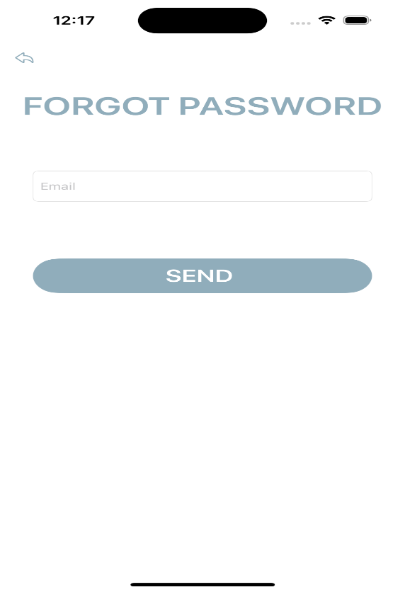

**6.4 Global Search:**

It allows the end users to perform search operations within an application. It searches across multiple forms for records that match a word or phrase that users type in the search area.

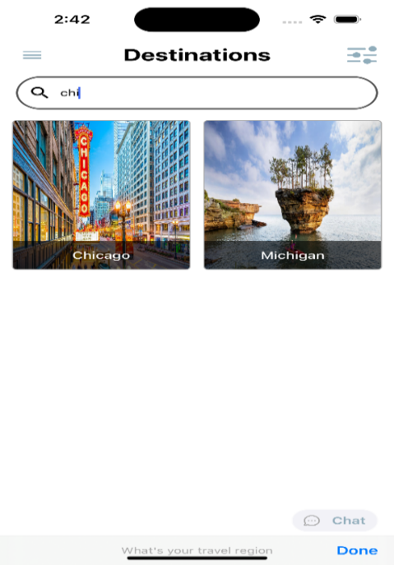

**6.5 Live Chat:**

Customers can communicate with customer service personnel in real time. Customers can chat with the application's admin at any moment, which allows for rapid dialogue rather than needing to phone or send an email.

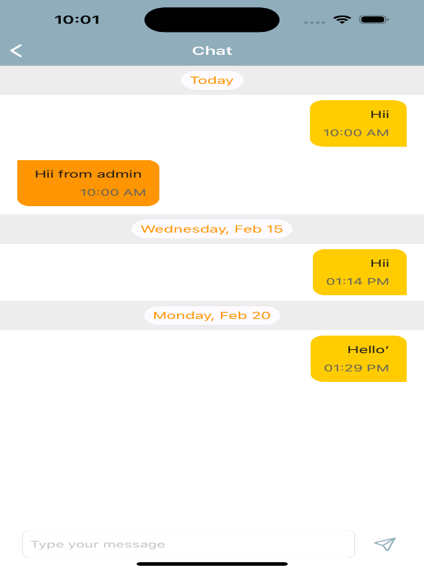

**6.6 Filtering Data:**

It enables you to filter a set of data based on criteria you specify. It presents facts in an organized manner, allowing the user to quickly determine their needs. Users can select the results based on several criteria such as season and group size.

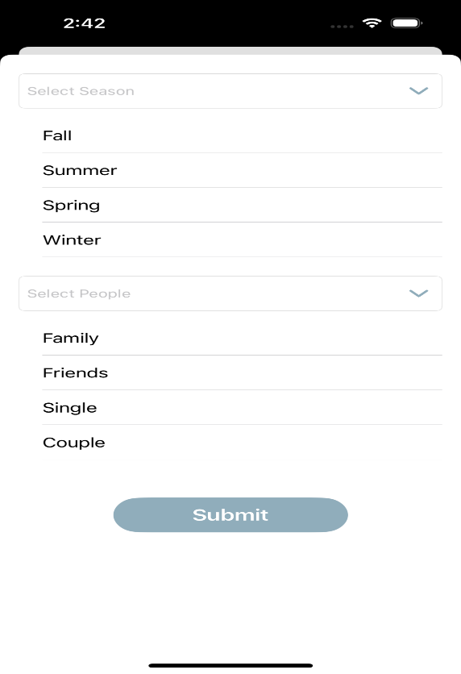

**6.7 Calendar in Wishlist Screen:**

It enables customers to choose the date of their trip directly from the calendar. This makes it easier to identify the day because we can see it instead of hunting for our own

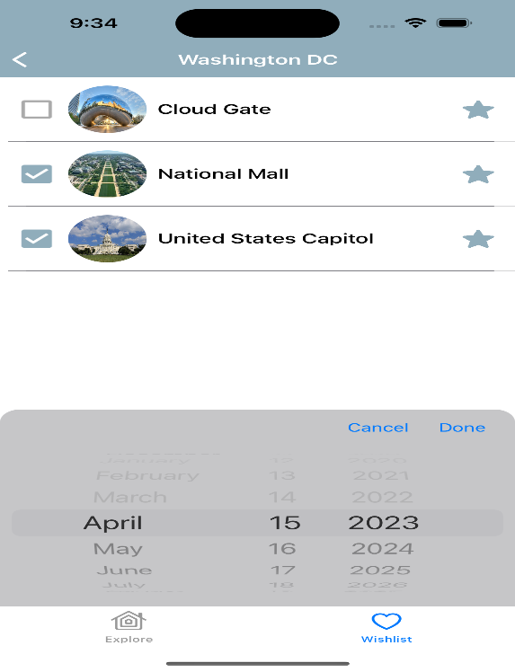

**6.8 Ratings and Reviews of the trip:**

Customers can select the date of their vacation directly from the calendar. This makes identifying the day easier because we can see it rather than searching for our own.

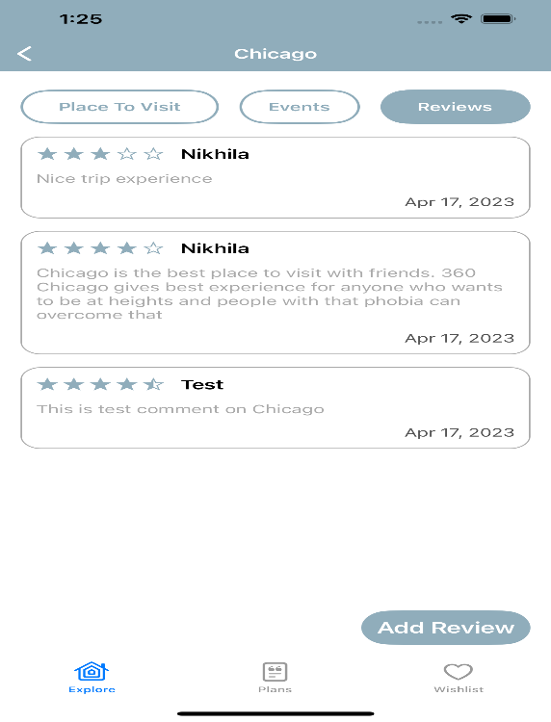

**6.9 Payment Getaway:**

It will be a third-party platform that applications will use to allow users to make payments through them. It notifies the bank of the fraud detection and authorizes the payment.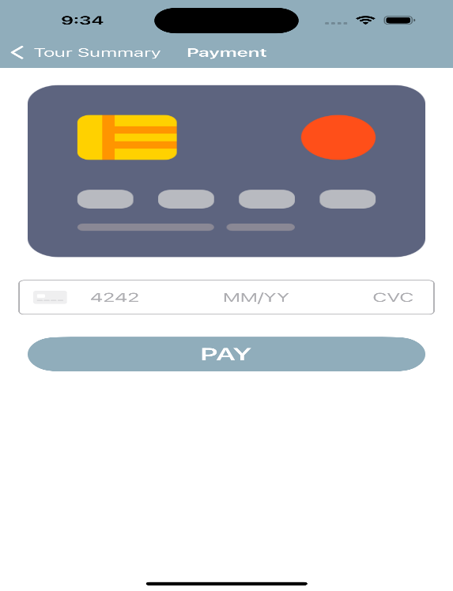

**6.10 History of Trips:**

It allows users to access past and prospective bookings from their profile page. This information is useful for anyone who wants to share their previous travel specifics with their friends.

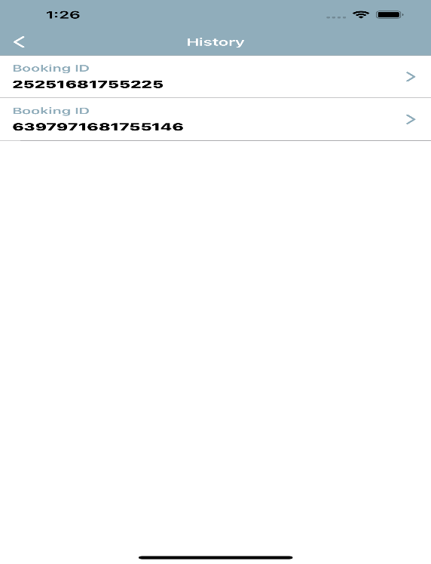

1. **Technical Manual**

**7.1 Targeted Audience:** No one knows the genuine thing until they experience it, as everyone says. As a result, our initiative began from our own experiences. As students in new cities, we have limited understanding of the many tourist attractions nearby. As a result, we created an application that considers all these elements and assists users in saving crucial time and money.

**7.2 Purpose:** The goal of our project is to create an application that provides information about all of the locations and saves the user time and money.

**7.3 Scope:** Our project's primary goal is to make it simple for users to utilize our services.

**7.4 Software installations:**

1. Xcode
2. Firebase

**7.5 List of Packages:**

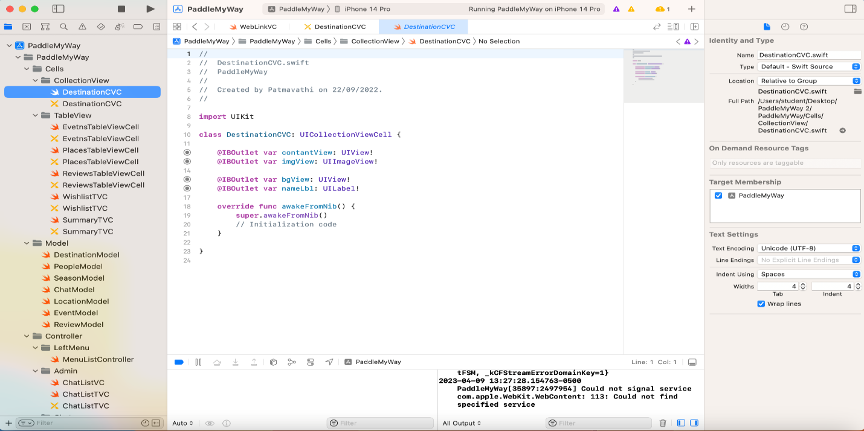

**UIKit:**

The IOS Framework UIKit implements the standard UI components for IOS Applications.

Creating an app with UIKit is a piece of cake. In all circumstances, you'll utilize Xcode, Apple's IDE for iOS and MacOS development. UIKit is an interface kit that can help you enhance your design workflow. They also encourage the reuse of components rather than the creation of new ones from scratch.

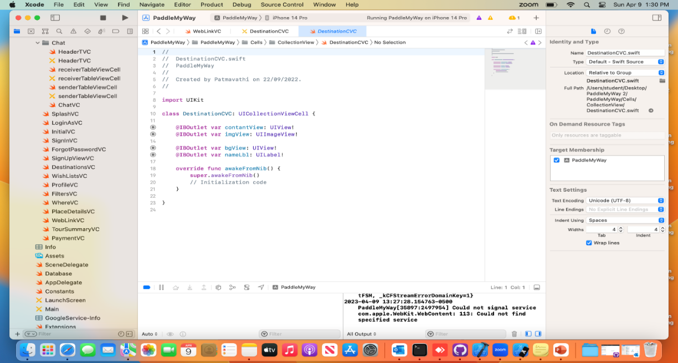

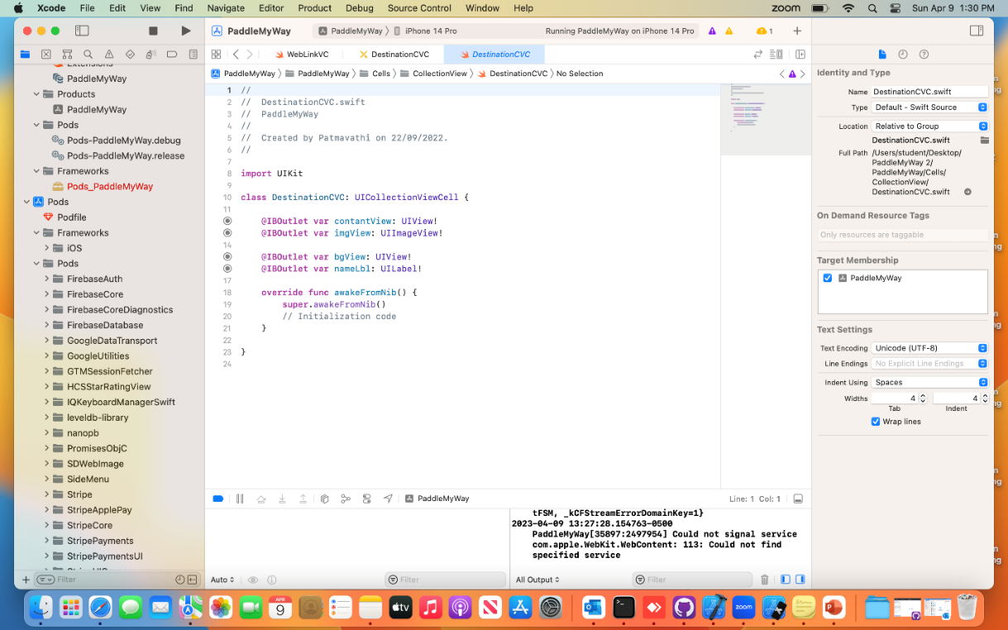

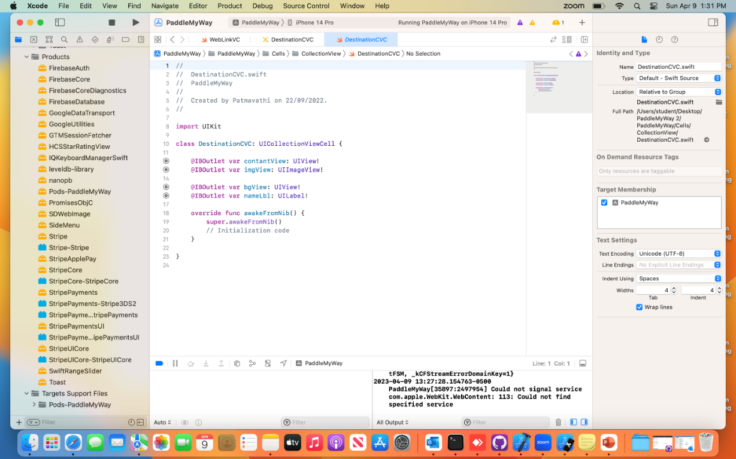

**HCSStarRatingView:**

* HCSStarRatingView is a UIControl subclass that provides a simple star rating interface to users.
* It works with all device resolutions and, while it doesn't require any photos to create the stars, you can offer your own if you want.
* It fully supports Voiceover, users with special needs should be able to read and interact with it.
* It is applied by MIT license, more information can be found in the LICENSE file.

**7.6 Side Navigation Bar:**

This controller gives the user flexibility to scroll the application screen up and down to increase the feasibility of application.

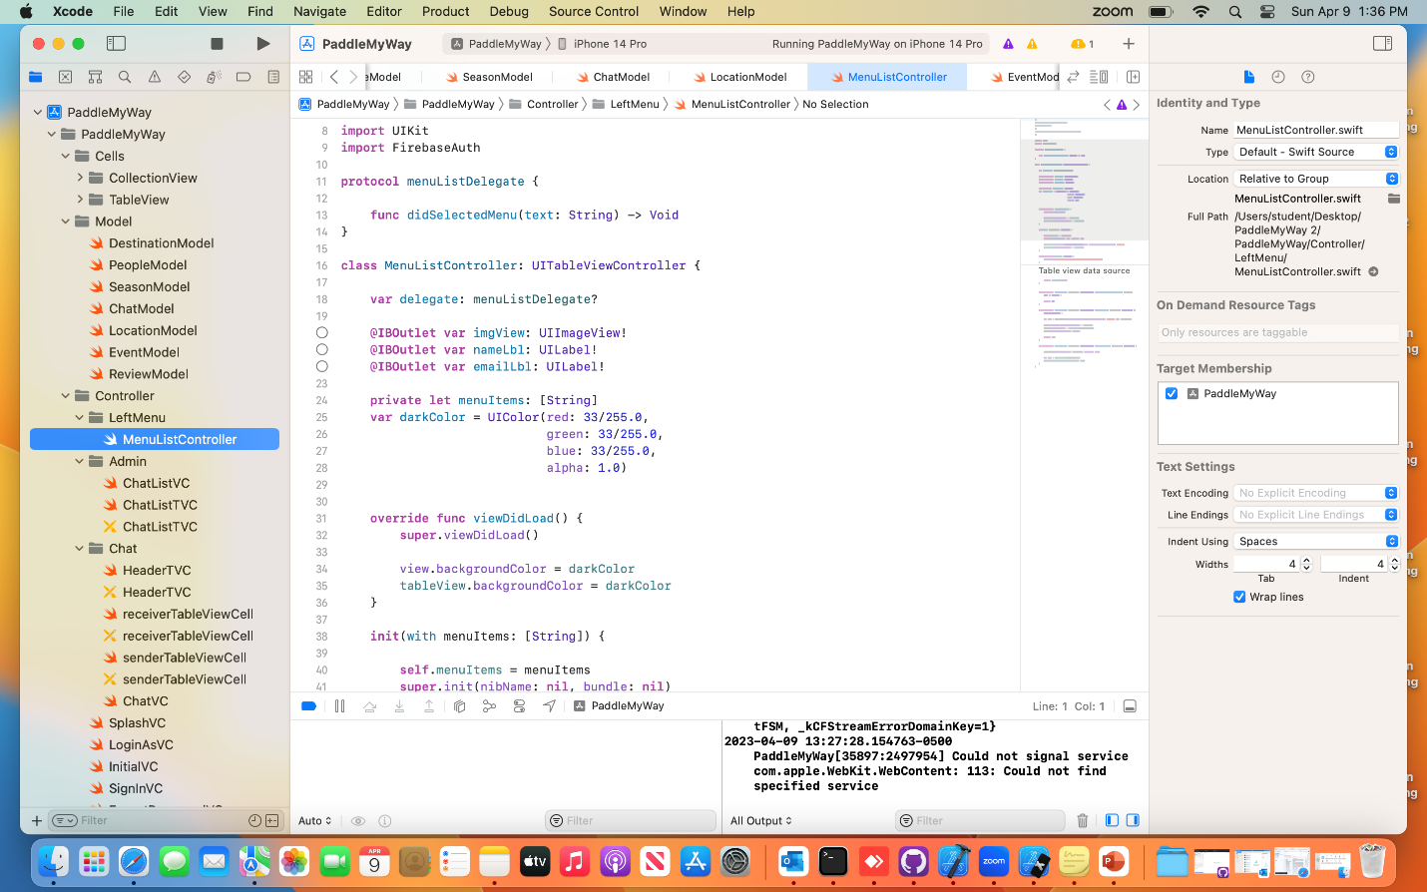

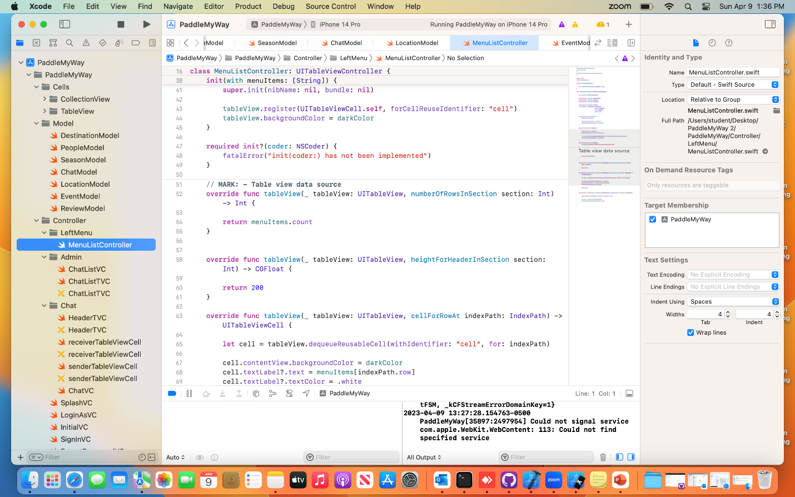

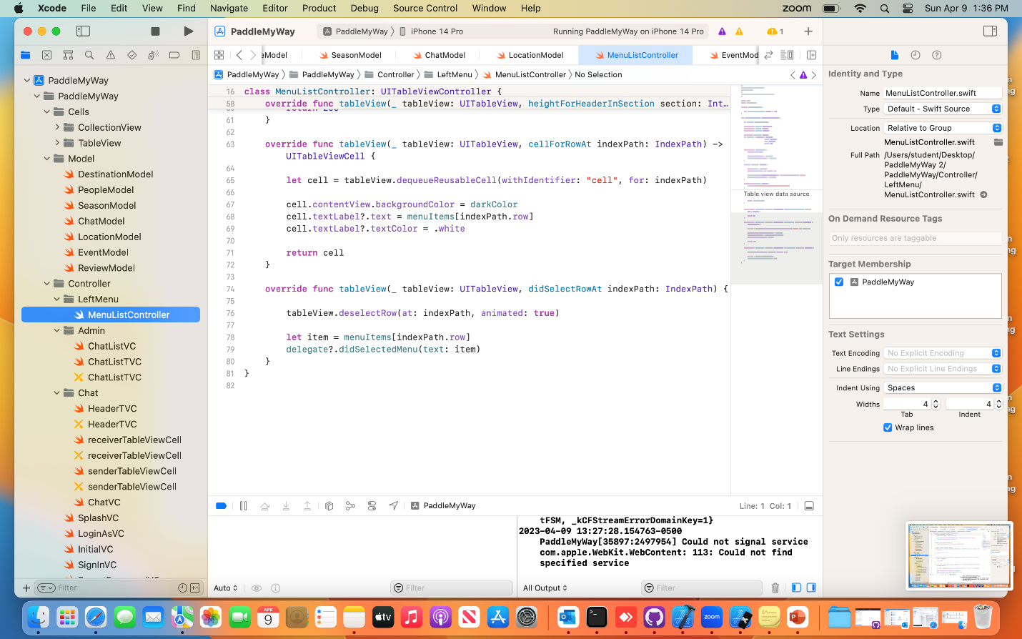

**Foundation:**

The Foundation framework is used in nearly all Swift projects. It provides both a base layer of functionality for fundamentals like strings, collections, and dates, as well as setting conventions for writing great Swift code.

You need to import Foundation if you are using things like Date or Attributed String or other APIs that aren't a part of the Swift Standard Library or a specialized framework. Note that import SwiftUI also includes Foundation. So, it is not required specifically.

**7.7 Cells Package:**

This is important for inserting table material into the program and for designing the application'sUI.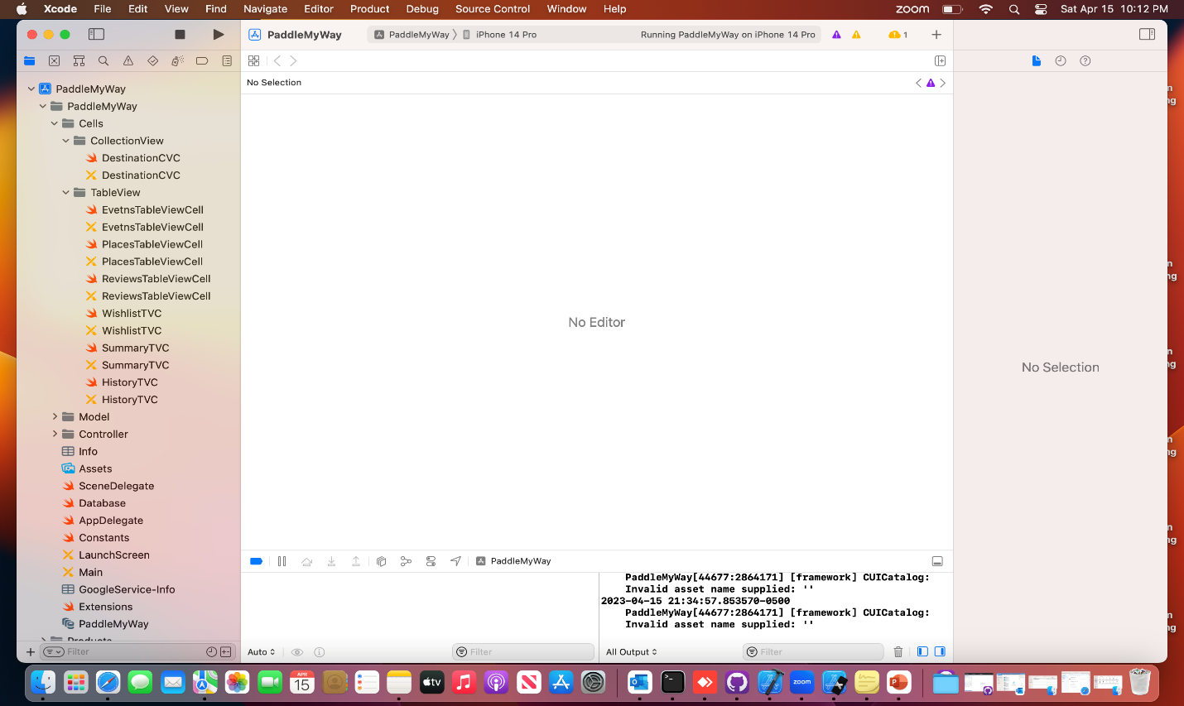

**FireBase:**

Firebase is a mobile backend-as-a-service that provides powerful features for building mobile apps. Firebase has three core services: Realtime database, User authentication, Hosting.

**7.8 Models Package**

**SDWebImage:**

This library offers a cache-compatible async image downloader. For ease of use, categories were added for UI components including UIImageView, UIButton, and MKAnnotationView.

SwiftUI’ s SDWebImageSwiftUI is an SDWebImage-based image loading framework.

All the features you love from SDWebImage, including async image loading, memory/disk caching, animated image playback, and performance, are included.

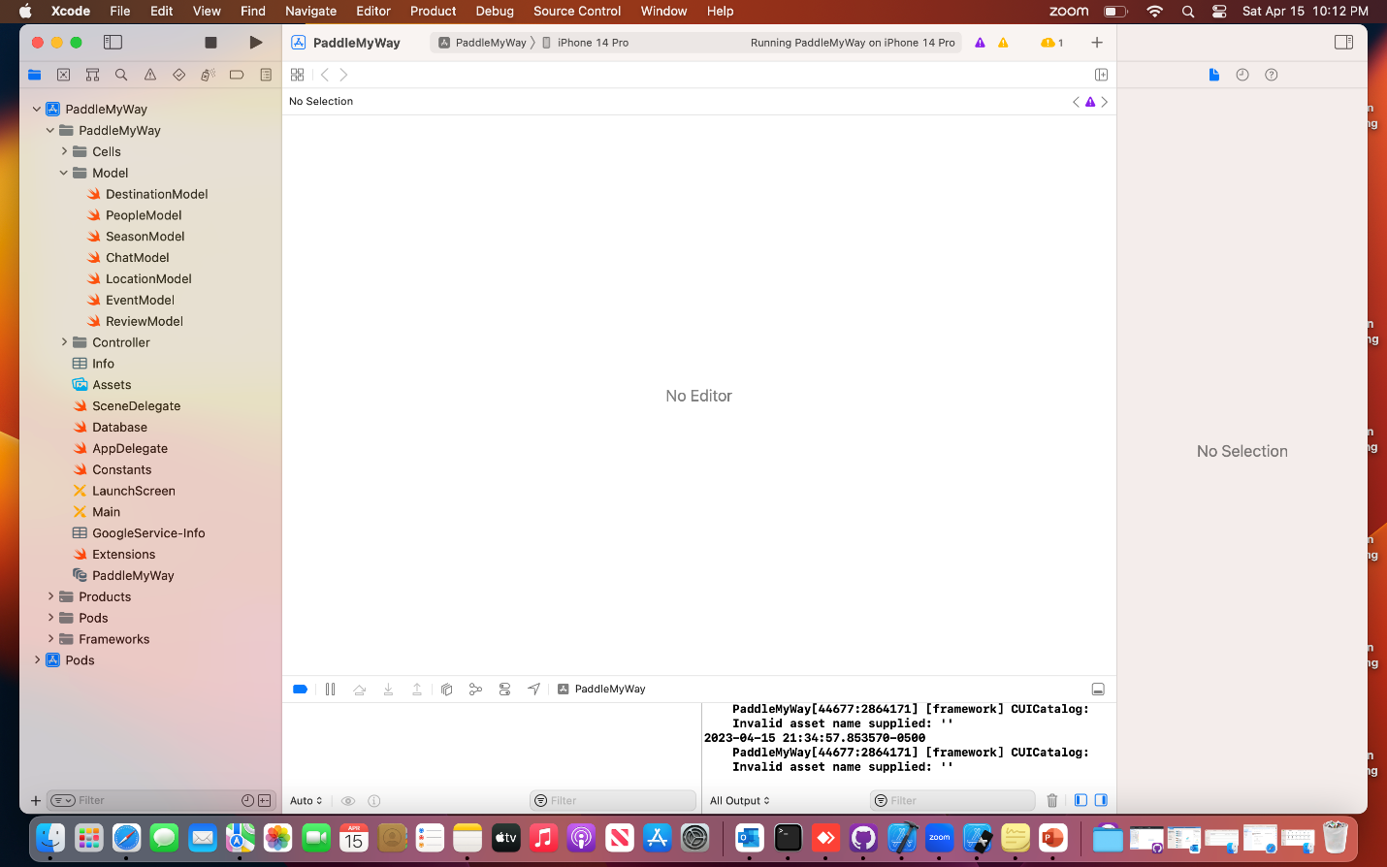

**SideMenu:**

Swift was used to create the straightforward and functional SideMenu side menu control.

Without writing a single line of code, it can be implemented in Storyboard. There are eight common animation options available, including a parallax effect if you want something out of the ordinary.

without the need to write a ton of proprietary code, highly configurable. allows for one-handed continuous swiping between side menus on both sides. global settings for the menu. One setup is required for all screens.

Since this control uses custom transitions, menus can be presented and dismissed in the same ways as any other view controller. View controllers are used for animations rather than snapshots. rotates the screen and modifies the height of the in-call status bar appropriately.

**DestinationModel**

Using key values, this model obtains information from the firebase about each destination. The places are assigned in accordance with each ID. The proposed destination considers the type of group trip and the time of year the users are traveling.

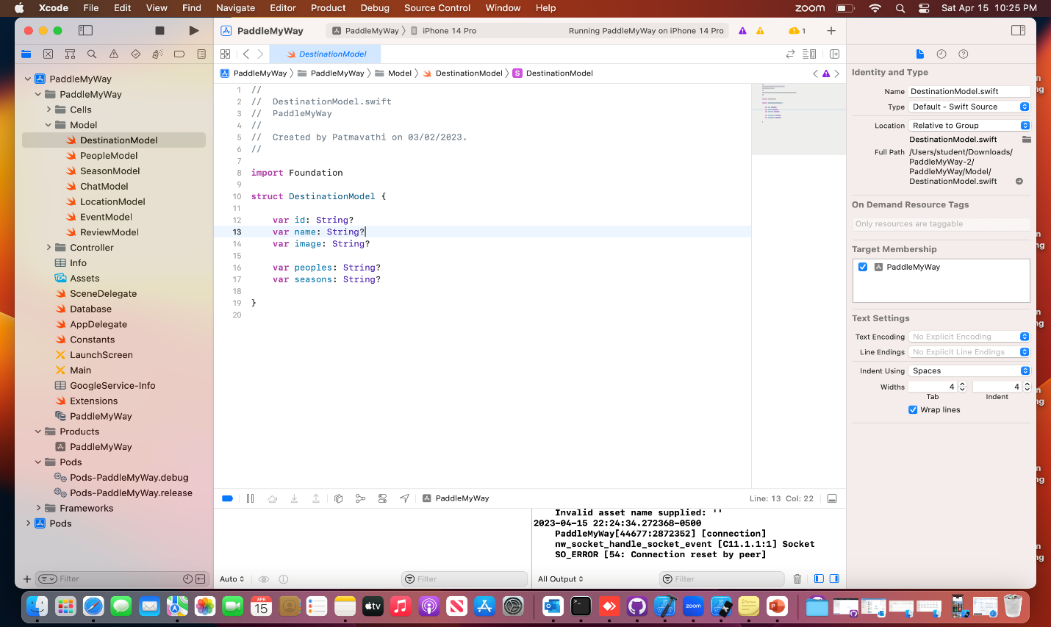

**PeopleModel**

This Model was developed to retrieve information about individuals using their ID.

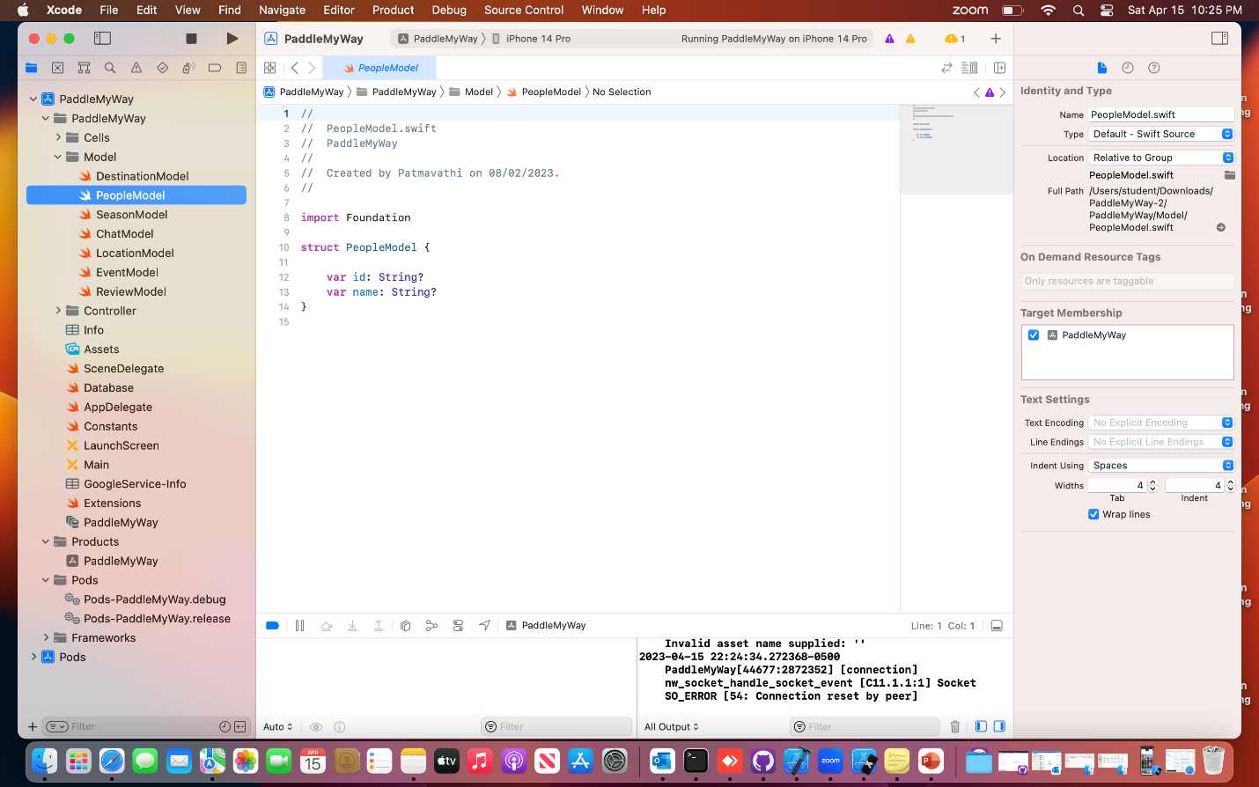

**Stripe:**

With the Stripe iOS SDK, creating a top-notch payment experience for your iOS app is quick and simple. We offer robust and adaptable UI screens and components that may be utilized right out of the box to gather payment information from your users. We also make available the low-level APIs that drive those UIs so you may create an entirely unique experience.

**EventModel:**

Based on the Key values, this model retrieves information from Firebase regarding each event. It retrieves information such as the event's date, category, and link to book the event and acquire additional information about it.

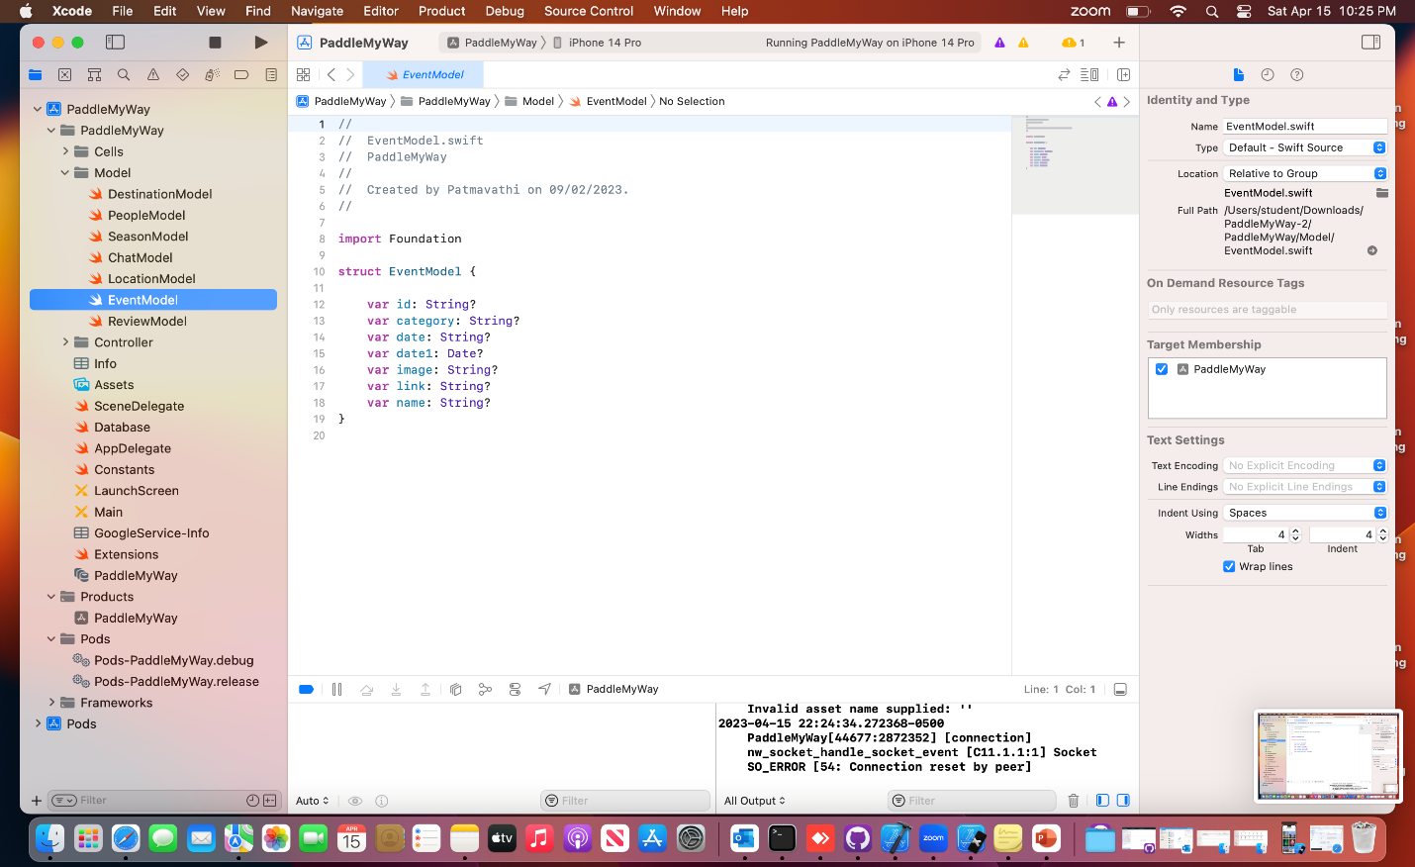

**Toast:**

SimpleToast is a straightforward, lightweight, adaptable, and basic SwiftUI framework for displaying toasts and pop-up notifications inside iOS or MacOS applications. It is also possible to use the library to display straightforward modals due to its flexibility to display any content.

Always at the edges of the view it is attached to, the toast is visible. Make sure there is adequate room for rendering the toast in the view. The toast should ideally be attached to the outermost view or, if available, the navigation view.

**Review Model**

When users enter reviews for each trip in the application, a review model is created to store them all in Firebase. The review screen shows the reviewer's name, rating, and the date of the review.

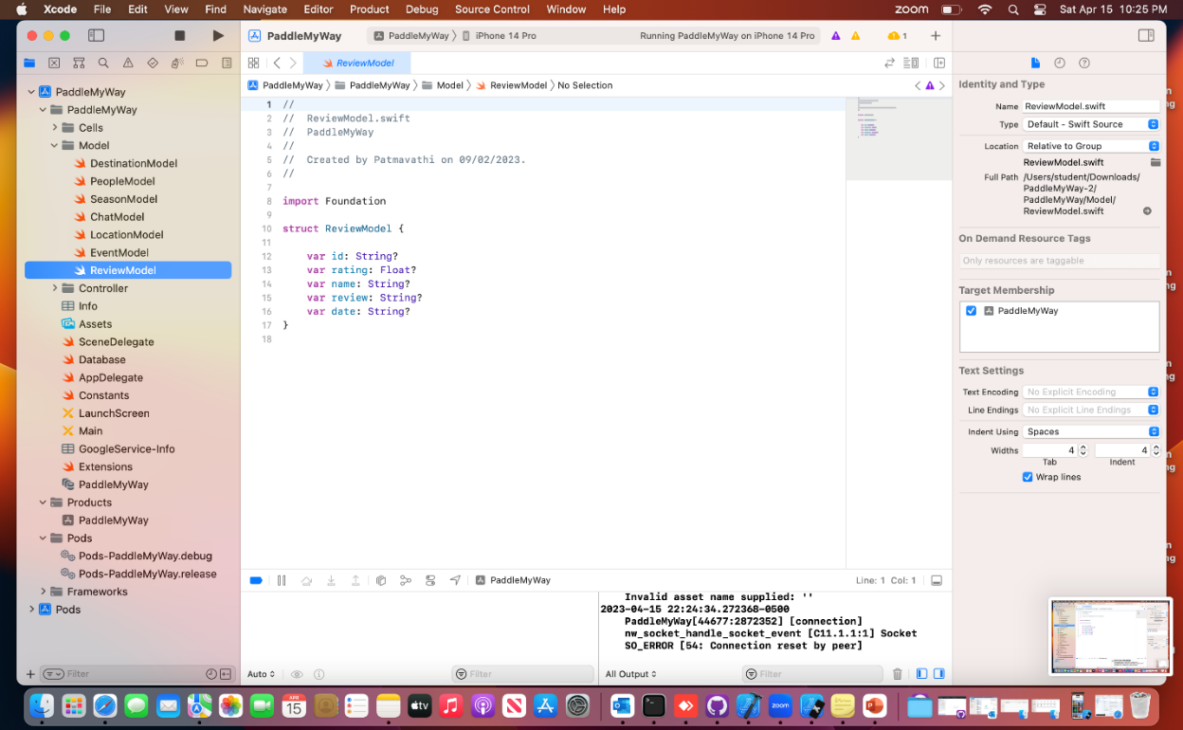

**SeasonModel**

This Model displays details about the season the user travels.

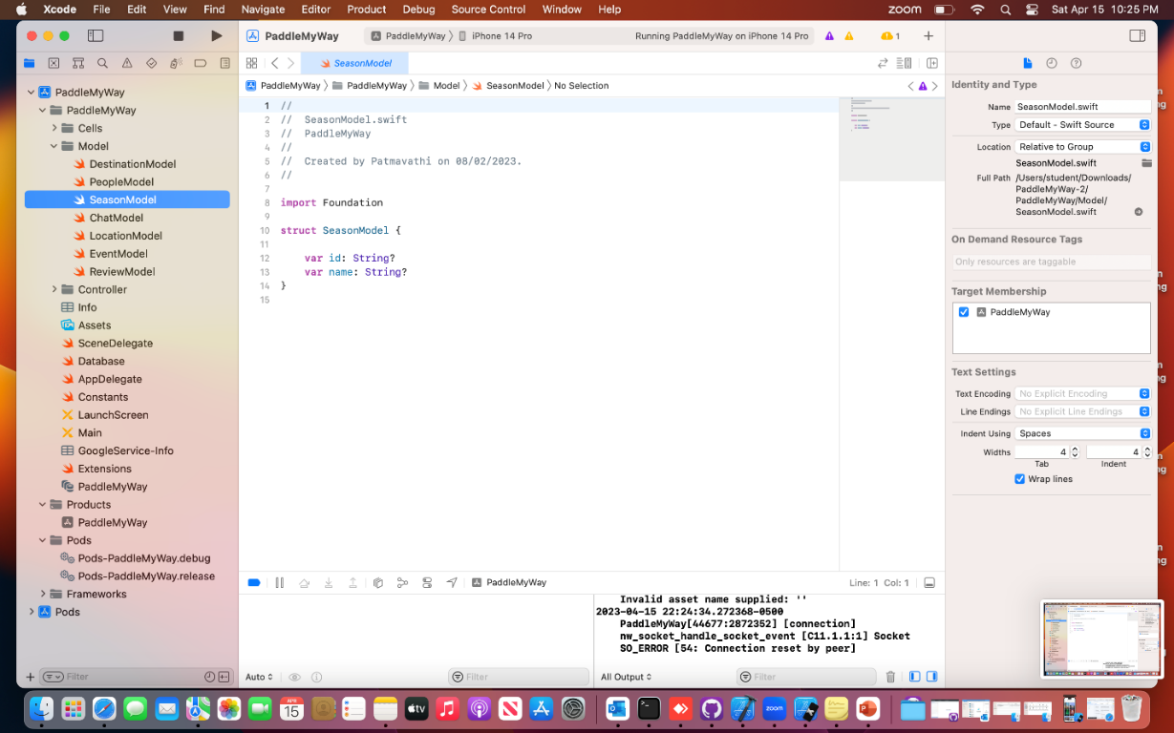

**ChatModel**

The chat model is important because it allows users to communicate with customer support representatives right away and have their questions answered. Using this Chat model, the user's name, the date, the time, and any messages they have sent are displayed.

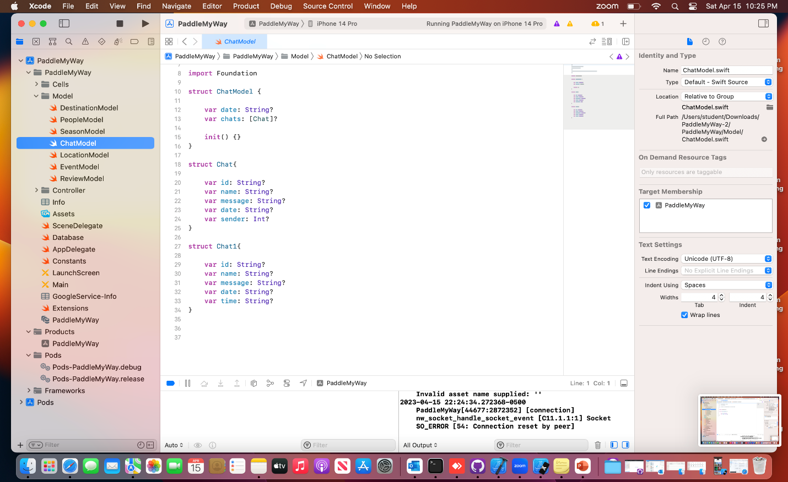

**IQKeyboardManagerSwift:**

A codeless drop-in universal library can prevent keyboard sliding up and cover UITextField/UITextView difficulties. There is no need to create any code, and no setup is necessary, among other benefits.

IQKeyboardManager is compatible with all orientations and the toolbar. It also contains some excellent extra features that allow you to adjust the distance from the text field, the behavior of the previous, next, and done buttons in the keyboard toolbar, the sound that plays when the user navigates through the form, and more.

**LocationModel:**

This model is used to provide location information for each destination. It informs the user about the location and cost of entrance.

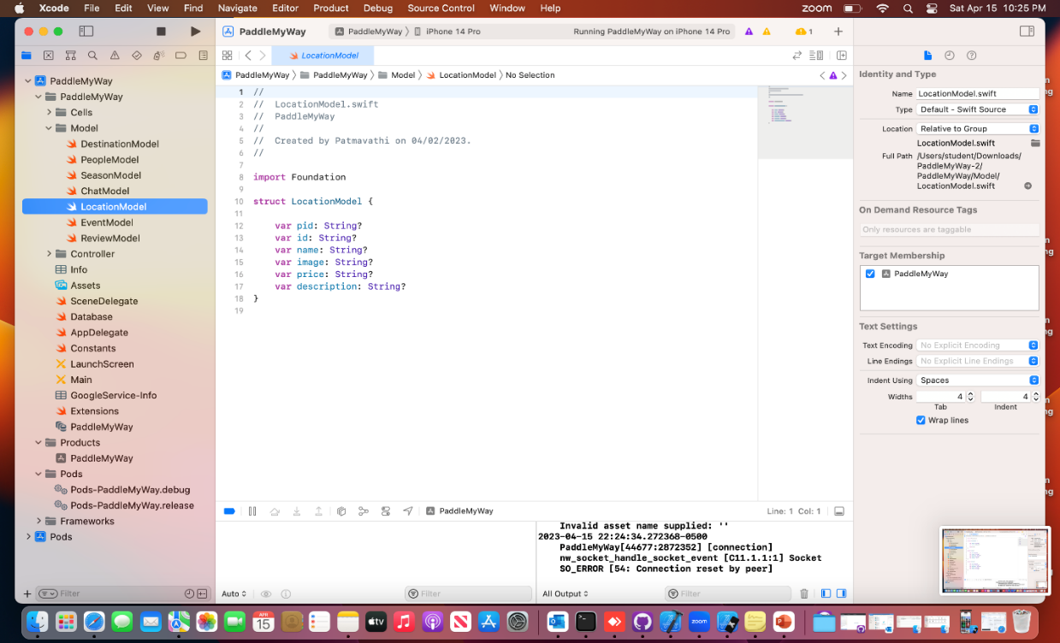

**7.9 Controllers Package**

Controller Package displays all the controllers connected to the application that aid in creation.

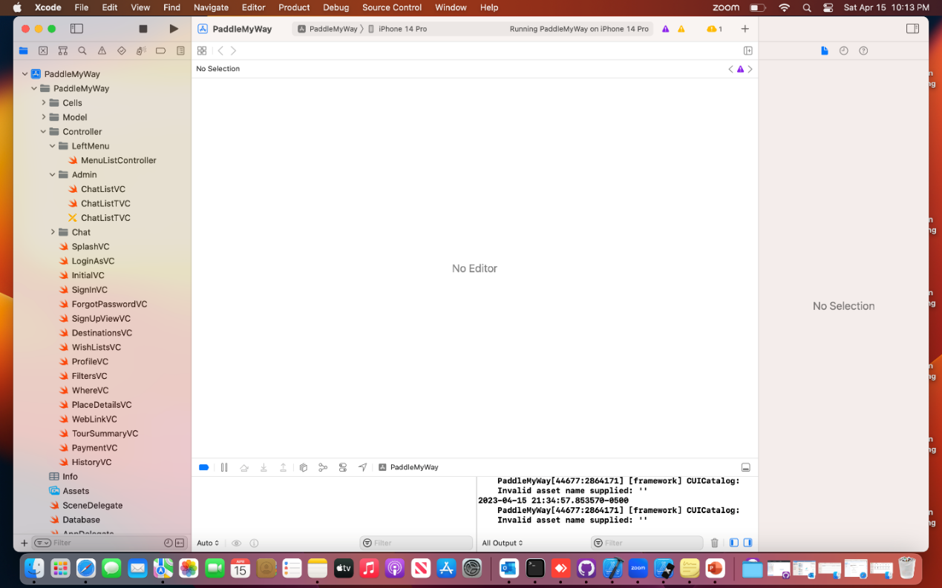

**7.10 Products and Pods Package**

This Package combines package dependencies to share code between projects or to use code from other developers.

